SIMULATION EXPERIMENT – 4
Design and Comparative Analysis of Butterworth, Chebyshev and Elliptic IIR Filters
Using MATLAB

Program:
clc;
clear;
close all;
%% =========================================================
% DESIGN AND COMPARATIVE ANALYSIS OF
% BUTTERWORTH, CHEBYSHEV-I AND ELLIPTIC IIR FILTERS
% =========================================================
%% 1. INPUT PARAMETERS
Fs = 1000; % Sampling frequency (Hz)
Fp = 100; % Passband edge (Hz)
Fst = 150; % Stopband edge (Hz)
Rp = 1; % Passband ripple (dB)
Rs = 40; % Stopband attenuation (dB)
% Normalized frequencies
Wp = Fp/(Fs/2);
Wst = Fst/(Fs/2);
%% =========================================================
% 2. CHEBYSHEV TYPE-I FORMULA
% =========================================================
epsilon = sqrt(10^(Rp/10)-1);
N_formula = acosh(sqrt((10^(Rs/10)-1)/(10^(Rp/10)-1))) ...
/ acosh(Fst/Fp);
N_theory = ceil(N_formula);
%% =========================================================
% 3. BUTTERWORTH FILTER
% =========================================================
[Nb,Wb] = buttord(Wp,Wst,Rp,Rs);
[bB,aB] = butter(Nb,Wb,'low');
%% =========================================================

% 4. CHEBYSHEV TYPE-I FILTER
% =========================================================
[Nc,Wc] = cheb1ord(Wp,Wst,Rp,Rs);
[bC,aC] = cheby1(Nc,Rp,Wc,'low');
%% =========================================================
% 5. ELLIPTIC FILTER
% =========================================================
[Ne,We] = ellipord(Wp,Wst,Rp,Rs);
[bE,aE] = ellip(Ne,Rp,Rs,We,'low');
%% =========================================================
% 6. DISPLAY INPUT PARAMETERS
% =========================================================
fprintf('\n====================================================\n');
fprintf(' IIR FILTER COMPARATIVE ANALYSIS\n');
fprintf('====================================================\n');
fprintf('\nINPUT PARAMETERS\n');
fprintf('Sampling Frequency = %.2f Hz\n',Fs);
fprintf('Passband Edge Frequency = %.2f Hz\n',Fp);
fprintf('Stopband Edge Frequency = %.2f Hz\n',Fst);
fprintf('Passband Ripple = %.2f dB\n',Rp);
fprintf('Stopband Attenuation = %.2f dB\n',Rs);
%% =========================================================
% 7. CHEBYSHEV FORMULA RESULTS
% =========================================================
fprintf('\nCHEBYSHEV TYPE-I FORMULA\n');
fprintf('Ripple factor epsilon = %.4f\n',epsilon);
fprintf('Calculated order = %.4f\n',N_formula);
fprintf('Theoretical minimum N = %d\n',N_theory);
%% =========================================================
% 8. FILTER ORDER COMPARISON
% =========================================================
fprintf('\n====================================================\n');
fprintf(' FILTER ORDER COMPARISON\n');
fprintf('====================================================\n');
fprintf('Butterworth Order = %d\n',Nb);
fprintf('Chebyshev Type-I Order = %d\n',Nc);
fprintf('Elliptic Order = %d\n',Ne);
%% =========================================================

% 9. COEFFICIENTS
% ==========================================================
fprintf('\n====================================================\n');
fprintf(' BUTTERWORTH COEFFICIENTS\n');
fprintf('====================================================\n');
fprintf('Numerator b =\n');
disp(bB);
fprintf('Denominator a =\n');
disp(aB);
fprintf('\n====================================================\n');
fprintf(' CHEBYSHEV TYPE-I COEFFICIENTS\n');
fprintf('====================================================\n');
fprintf('Numerator b =\n');
disp(bC);
fprintf('Denominator a =\n');
disp(aC);
fprintf('\n====================================================\n');
fprintf(' ELLIPTIC COEFFICIENTS\n');
fprintf('====================================================\n');
fprintf('Numerator b =\n');
disp(bE);
fprintf('Denominator a =\n');
disp(aE);
%% =========================================================
% 10. FREQUENCY RESPONSES
% ==========================================================
N = 4096;
[HB,f] = freqz(bB,aB,N,Fs);
[HC,~] = freqz(bC,aC,N,Fs);
[HE,~] = freqz(bE,aE,N,Fs);
MB = 20*log10(abs(HB)+eps);
MC = 20*log10(abs(HC)+eps);
ME = 20*log10(abs(HE)+eps);
%% =========================================================
% 11. PASSBAND RIPPLE
% ==========================================================

P = f <= Fp;
Ripple_B = max(MB(P))-min(MB(P));
Ripple_C = max(MC(P))-min(MC(P));
Ripple_E = max(ME(P))-min(ME(P));
%% =========================================================
% 12. STOPBAND ATTENUATION
% ==========================================================
S = f >= Fst;
Stop_B = -max(MB(S));
Stop_C = -max(MC(S));
Stop_E = -max(ME(S));
%% =========================================================
% 13. PERCENTAGE DEVIATION
% ==========================================================
Dev_C_Ripple = abs(Ripple_C-Rp)/Rp*100;
Dev_B_Stop = abs(Stop_B-Rs)/Rs*100;
Dev_C_Stop = abs(Stop_C-Rs)/Rs*100;
Dev_E_Stop = abs(Stop_E-Rs)/Rs*100;
%% =========================================================
% 14. TRANSITION CHARACTERISTICS
% ==========================================================
TransitionBW = Fst-Fp;
%% =========================================================
% 15. DISPLAY PERFORMANCE
% ==========================================================
fprintf('\n====================================================\n');
fprintf(' FILTER PERFORMANCE\n');
fprintf('====================================================\n');
fprintf('\nPASSBAND RIPPLE\n');
fprintf('Butterworth = %.4f dB\n',Ripple_B);
fprintf('Chebyshev Type-I = %.4f dB\n',Ripple_C);
fprintf('Elliptic = %.4f dB\n',Ripple_E);
fprintf('\nSTOPBAND ATTENUATION\n');
fprintf('Butterworth = %.4f dB\n',Stop_B);
fprintf('Chebyshev Type-I = %.4f dB\n',Stop_C);
fprintf('Elliptic = %.4f dB\n',Stop_E);

fprintf('\nCHEBYSHEV RIPPLE DEVIATION\n');
fprintf('Specified Ripple = %.2f dB\n',Rp);
fprintf('Measured Ripple = %.4f dB\n',Ripple_C);
fprintf('Percentage Deviation = %.4f %%\n',Dev_C_Ripple);
fprintf('\nTRANSITION CHARACTERISTICS\n');
fprintf('Passband Edge = %.2f Hz\n',Fp);
fprintf('Stopband Edge = %.2f Hz\n',Fst);
fprintf('Transition Band = %.2f Hz\n',TransitionBW);
%% =========================================================
% 16. MAGNITUDE RESPONSE
% ==========================================================
figure;
plot(f,MB,'LineWidth',1.5);
hold on;
plot(f,MC,'LineWidth',1.5);
plot(f,ME,'LineWidth',1.5);
grid on;
xlabel('Frequency (Hz)');
ylabel('Magnitude (dB)');
title('Comparison of IIR Filter Magnitude Responses');
legend('Butterworth','Chebyshev Type-I','Elliptic');
xlim([0 250]);
ylim([-80 5]);
xline(Fp,'--','Fp = 100 Hz');
xline(Fst,'--','Fst = 150 Hz');
yline(-Rp,'--','Rp = -1 dB');
yline(-Rs,'--','Rs = -40 dB');
hold off;
%% =========================================================
% 17. PHASE RESPONSE
% ==========================================================
Phase_B = unwrap(angle(HB))*180/pi;
Phase_C = unwrap(angle(HC))*180/pi;
Phase_E = unwrap(angle(HE))*180/pi;

figure;
plot(f,Phase_B,'LineWidth',1.2);
hold on;
plot(f,Phase_C,'LineWidth',1.2);
plot(f,Phase_E,'LineWidth',1.2);
grid on;
xlabel('Frequency (Hz)');
ylabel('Phase (degrees)');
title('Comparison of IIR Filter Phase Responses');
legend('Butterworth','Chebyshev Type-I','Elliptic');
xlim([0 250]);
hold off;
%% =========================================================
% 18. FILTER ORDER GRAPH
% ==========================================================
figure;
bar([Nb Nc Ne]);
set(gca,'XTick',1:3);
set(gca,'XTickLabel',...
{'Butterworth','Chebyshev-I','Elliptic'});
ylabel('Filter Order');
xlabel('Filter Type');
title('Comparison of IIR Filter Orders');
grid on;
Output
INPUT PARAMETERS
Sampling Frequency = 1000.00 Hz
Passband Edge Frequency = 100.00 Hz
Stopband Edge Frequency = 150.00 Hz
Passband Ripple = 1.00 dB
Stopband Attenuation = 40.00 dB
CHEBYSHEV TYPE-I FORMULA
Ripple factor epsilon = 0.5088
Calculated order = 6.2071

Theoretical minimum N = 7
====================================================
FILTER ORDER COMPARISON
====================================================
Butterworth Order = 12
Chebyshev Type-I Order = 6
Elliptic Order = 4
====================================================
BUTTERWORTH COEFFICIENTS
====================================================
Numerator b =
1.0e-03 *
Columns 1 through 4
0.0002 0.0027 0.0146 0.0488
Columns 5 through 8
0.1098 0.1757 0.2050 0.1757
Columns 9 through 12
0.1098 0.0488 0.0146 0.0027
Column 13
0.0002
Denominator a =
Columns 1 through 4
1.0000 -6.8844 22.4341 -45.5100
Columns 5 through 8
63.7725 -64.8501 48.9643 -27.6092
Columns 9 through 12
11.5218 -3.4662 0.7128 -0.0899
Column 13
0.0053

====================================================

CHEBYSHEV TYPE-I COEFFICIENTS
====================================================
Numerator b =
1.0e-03 *
Columns 1 through 4
0.0464 0.2782 0.6956 0.9274
Columns 5 through 7
0.6956 0.2782 0.0464
Denominator a =
Columns 1 through 4
1.0000 -4.8694 10.3807 -12.3367
Columns 5 through 7
8.5969 -3.3268 0.5586

====================================================
ELLIPTIC COEFFICIENTS
====================================================
Numerator b =
Columns 1 through 4
0.0197 -0.0171 0.0333 -0.0171
Column 5
0.0197
Denominator a =
Columns 1 through 4
1.0000 -3.0330 3.8118 -2.2911
Column 5
0.5554

====================================================
FILTER PERFORMANCE
====================================================
PASSBAND RIPPLE

Butterworth = 0.8033 dB
Chebyshev Type-I = 1.0000 dB
Elliptic = 1.0000 dB
STOPBAND ATTENUATION
Butterworth = 40.0198 dB
Chebyshev Type-I = 41.3365 dB
Elliptic = 40.0000 dB
CHEBYSHEV RIPPLE DEVIATION
Specified Ripple = 1.00 dB
Measured Ripple = 1.0000 dB
Percentage Deviation = 0.0000 %
TRANSITION CHARACTERISTICS
Passband Edge = 100.00 Hz
Stopband Edge = 150.00 Hz
Transition Band = 50.00 Hz

OUTPUT:
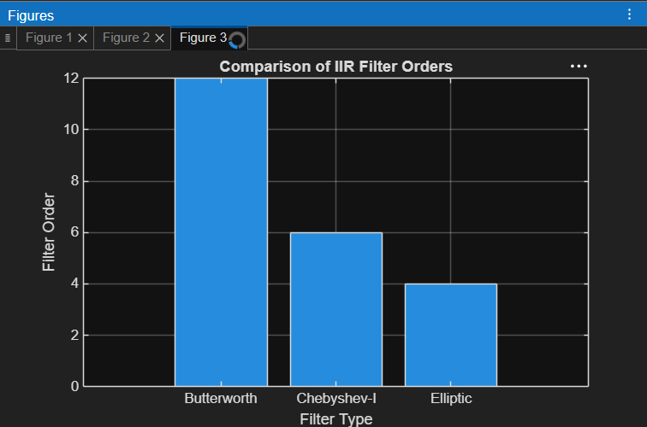
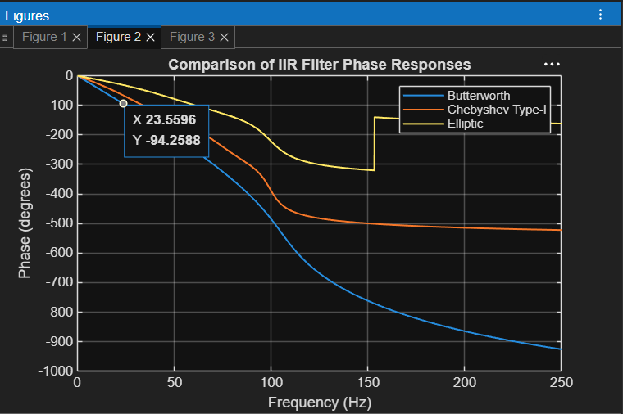
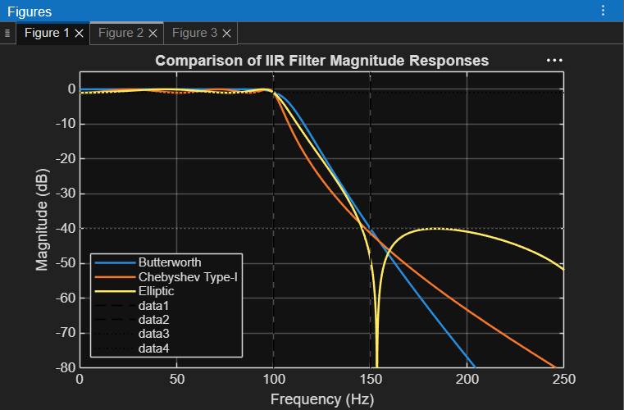

RESULT:
============================================
IIR FILTER COMPARATIVE ANALYSIS
============================================
INPUT PARAMETERS
Sampling Frequency = 1000.00 Hz
Passband Edge Frequency = 100.00 Hz
Stopband Edge Frequency = 150.00 Hz
Passband Ripple = 1.00 dB
Stopband Attenuation = 40.00 dB
CHEBYSHEV TYPE-I THEORETICAL ORDER
Ripple factor epsilon = 0.5088
Calculated order = 5.8507
Theoretical minimum order = 6
============================================
FILTER ORDER COMPARISON
============================================
Butterworth Order = 12
Chebyshev Type-I Order = 6
Elliptic Order = 4
============================================
BUTTERWORTH COEFFICIENTS
============================================
Numerator bB =
1.0e-03 *

0.0002 0.0027 0.0146 0.0488 0.1098 0.1757 0.2050 0.1757 0.1098 0.0488 0.0146 0.0027 0.0002
Denominator aB =
1.0000 -6.8844 22.4341 -45.5100 63.7725 -64.8501 48.9643 -27.6092 11.5218 -3.4662 0.7128 -0.0899 0.0053
============================================
CHEBYSHEV TYPE-I COEFFICIENTS
============================================
Numerator bC =
1.0e-03 *
0.0464 0.2782 0.6956 0.9274 0.6956 0.2782 0.0464
Denominator aC =
1.0000 -4.8694 10.3807 -12.3367 8.5969 -3.3268 0.5586
============================================
ELLIPTIC COEFFICIENTS
============================================
Numerator bE =
0.0197 -0.0171 0.0333 -0.0171 0.0197
Denominator aE =
1.0000 -3.0330 3.8118 -2.2911 0.5554

============================================
FILTER PERFORMANCE
============================================
PASSBAND RIPPLE
Butterworth = 0.8033 dB
Chebyshev Type-I = 1.0000 dB
Elliptic = 1.0000 dB
STOPBAND ATTENUATION
Butterworth = 40.0198 dB
Chebyshev Type-I = 41.3365 dB
Elliptic = 40.0000 dB
CHEBYSHEV TYPE-I RIPPLE DEVIATION
Specified Ripple = 1.00 dB
Measured Ripple = 1.0000 dB
Percentage Deviation = 0.0000 %
STOPBAND ATTENUATION DEVIATION
Butterworth = 0.0494 %
Chebyshev Type-I = 3.3413 %
Elliptic = 0.0000 %
TRANSITION CHARACTERISTICS
Passband Edge = 100.00 Hz
Stopband Edge = 150.00 Hz
Transition Bandwidth = 50.00 Hz
============================================
EXPERIMENT COMPLETED SUCCESSFULLY
============================================
Butterworth order = 12
Chebyshev Type-I order = 6
Elliptic order = 4
All three filter responses have been plotted.

